**15-Designe pattern**

**Strategy pattern**

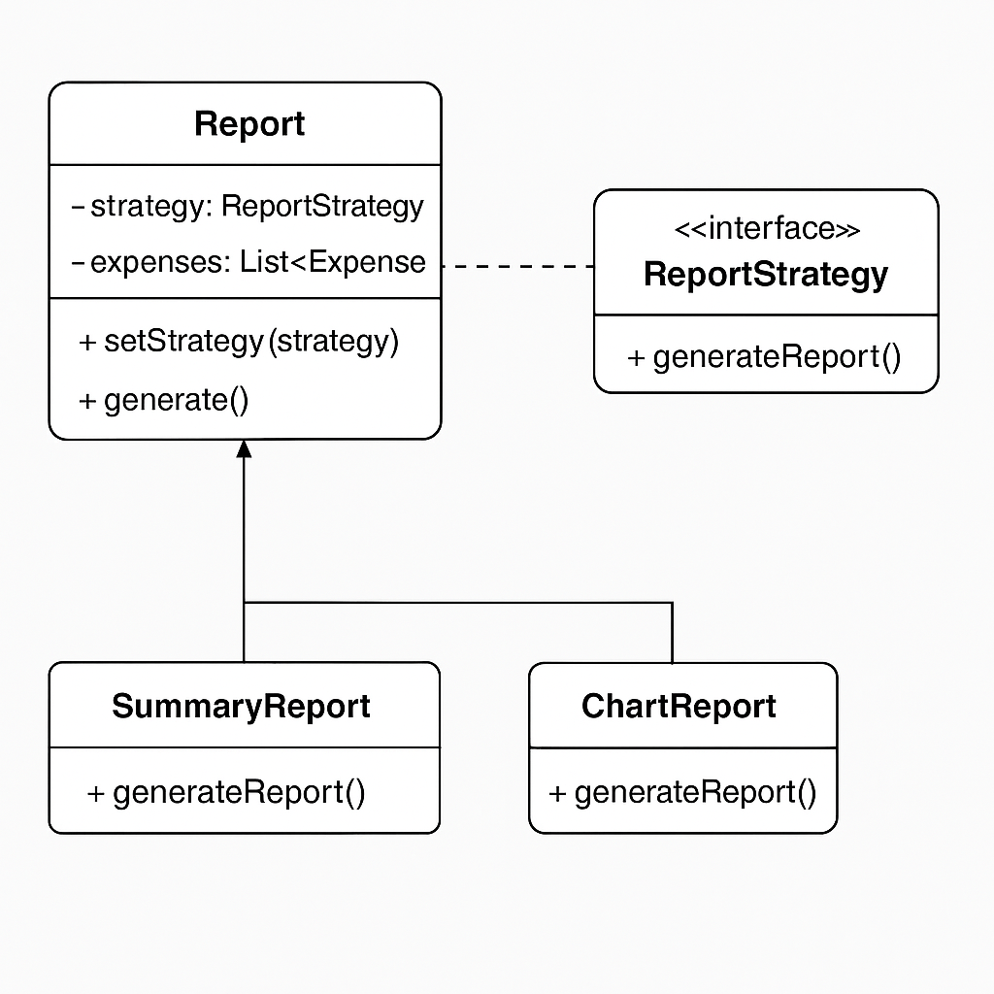the figure 15 This Report class generates different types of outputs (e.g., **summary**, **charts), Using** Strategy Pattern here lets us **plug and play different reporting algorithms** without changing the Report class.

**Figure 15: Strategy design pattern for reporting**